Report Week 3

* Continuation on analyzing speed transmission, frame dropped, error and power loss in 1G system setup with 15km spool. The system design was consisted of ONU, OLT, switch, Spirent, circulator, and Spool. Attenuator was used for introduced various of power loss on the system to testing the performance on the system. The netgear switch such in figure below was configured on the interface Netgear software. The VLAN port that have been use was tagged with 500 VLAN ID and transmit it through to ONU. It is important to take note that the configuration on VLAN port must be tagged or untagged so that the packet frame was not dropped. If the switch receive tagged VLAN then it is compulsory to configure the port receive to be tagged in preventing packet drop.

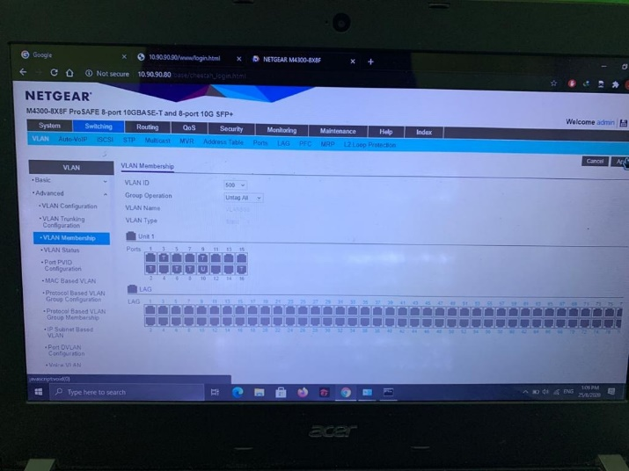

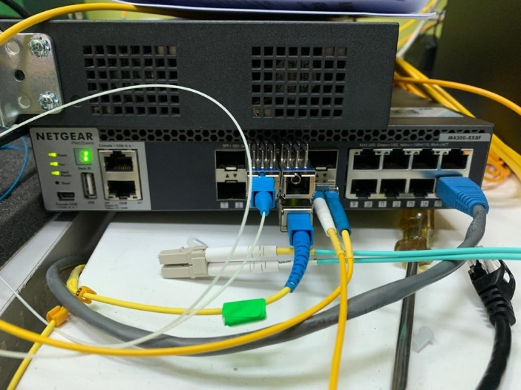

* Figure below shown the system setup on 1G system.

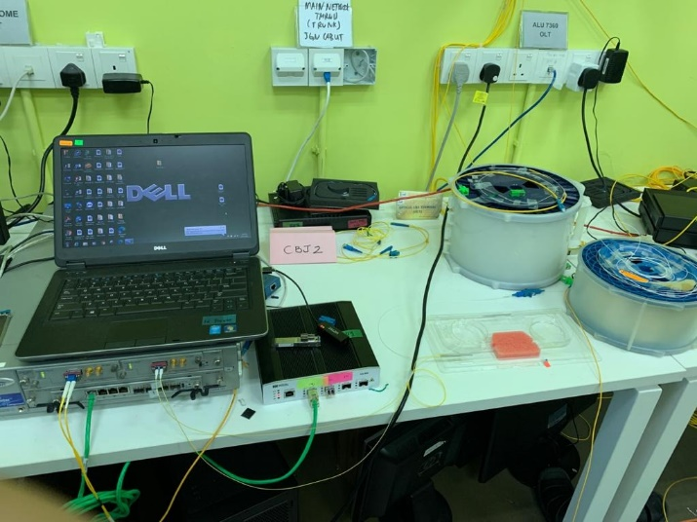

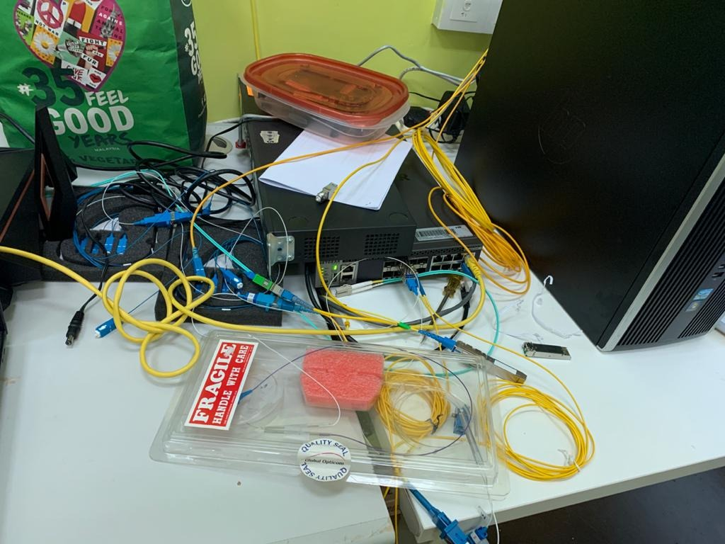

* In the lab, the 1G system testing design was used for 10G system setup. The transmission was successfully be transmit at 10G rate .
* Spirent test center software was used to monitor the speed transmission and packet loss. Figure below shows the interface taken from the experiment.

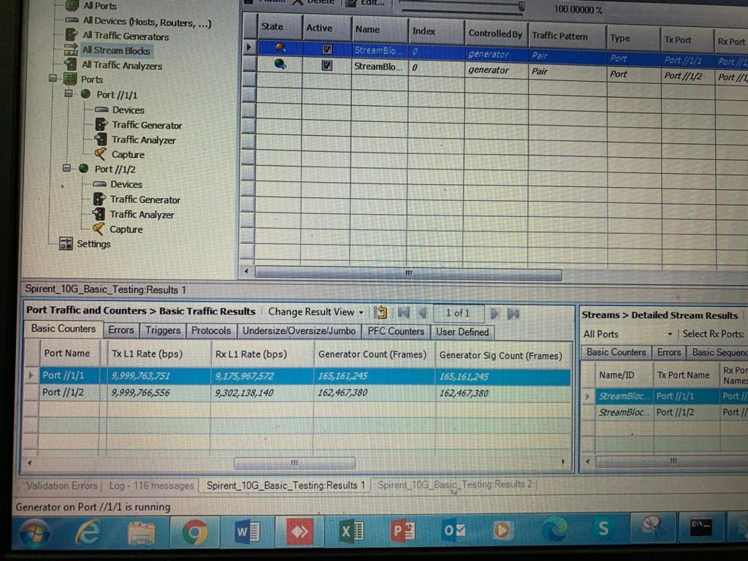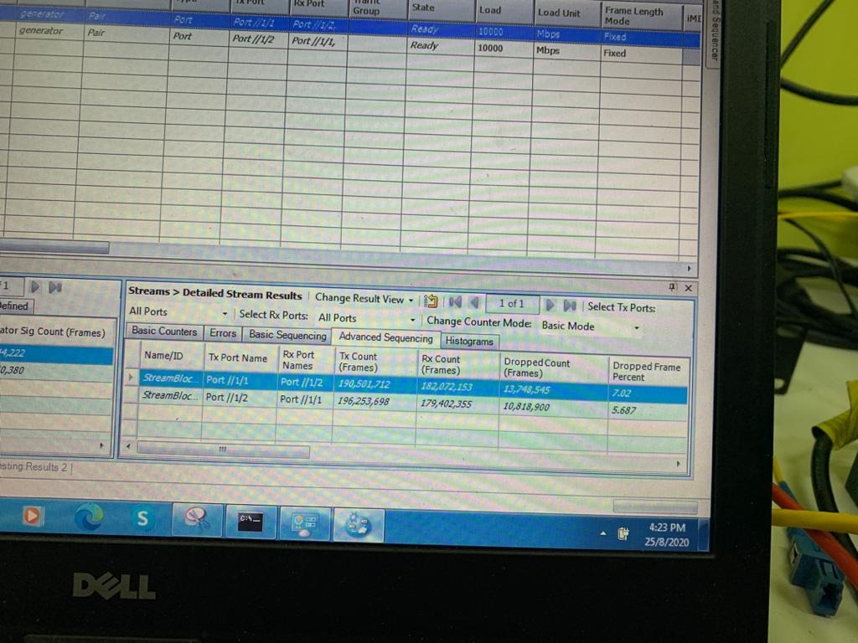

* The 10G system setup was implemented in real life scenario at CBJ2 to MMU. The first setup was at MMU. ONU, OLT, D-Link switch, Spirent, circulator, 1x2 splitter and 15km spool was placed at MMU. Figure below shows the system setup at MMU.

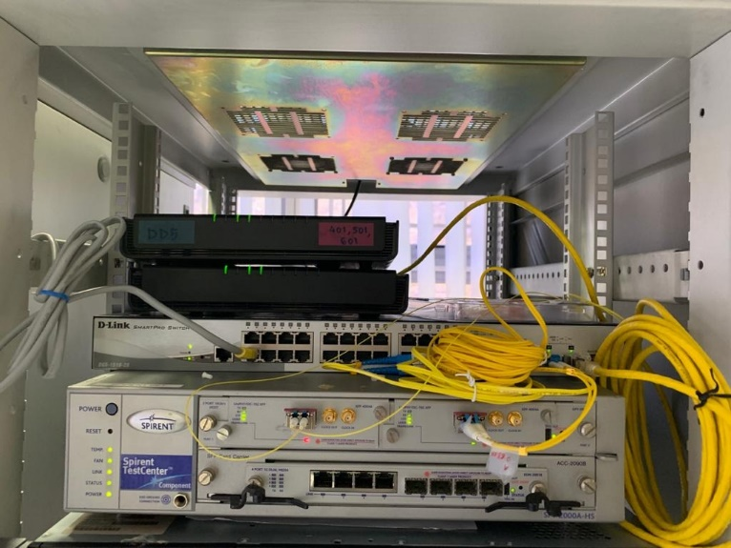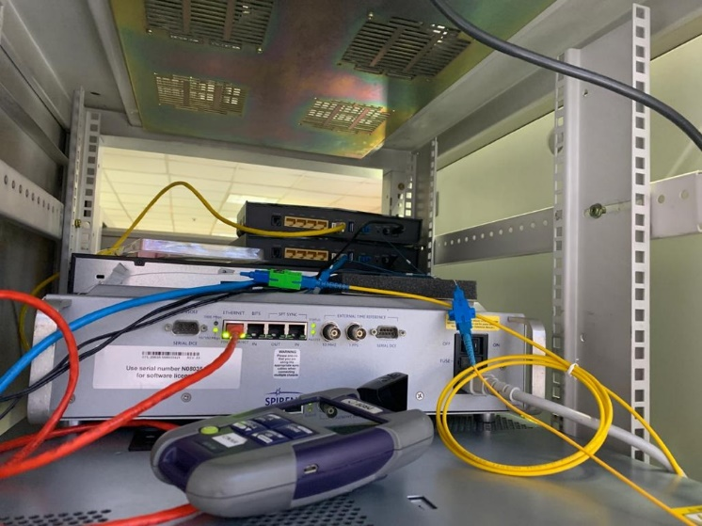

* Then D-Link switch need to be configured to give packet to access from CBJ2 to MMU. The configuration was made at D-Link interface such as figure below.

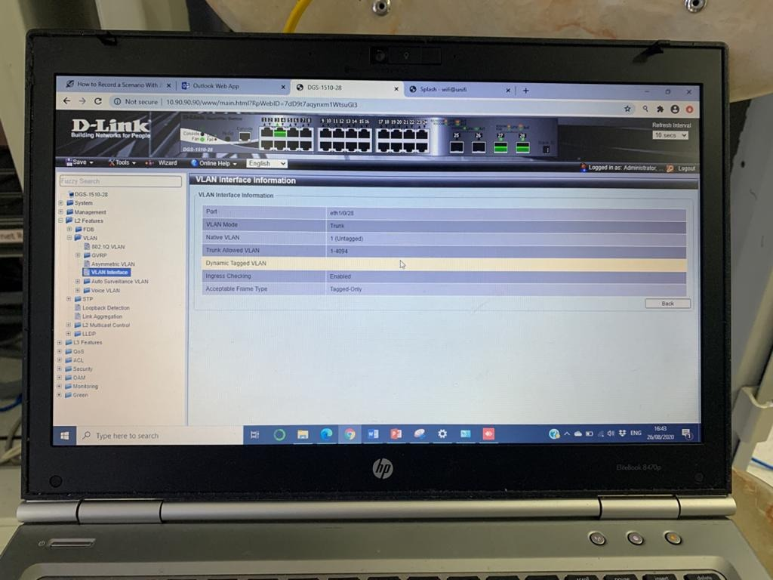

* Then the next setup was at CBJ2 which consist of Netgear switch, OLT, and a circulator. Unfortunately, the system setup was not pass through. Some troubleshooting was made at CBJ2 since the traffic does not pass through. All the component on MMU was taken to CBJ2 to have troubleshoot. Figure below shows that setup and troubleshooting was made at CBJ2.

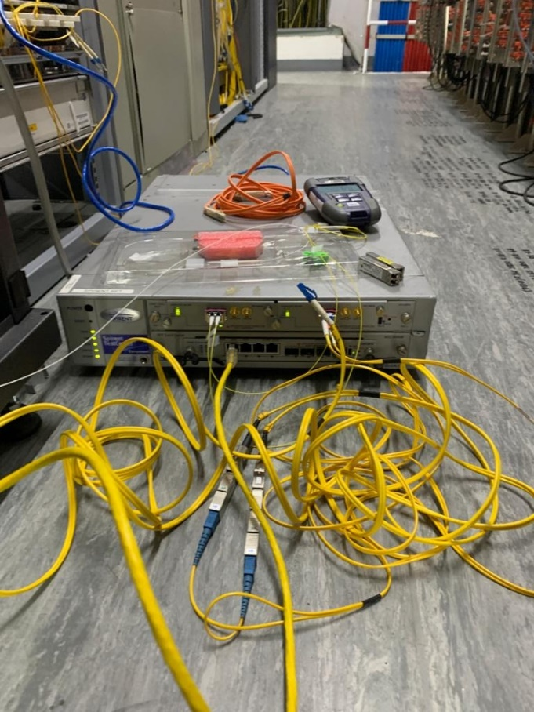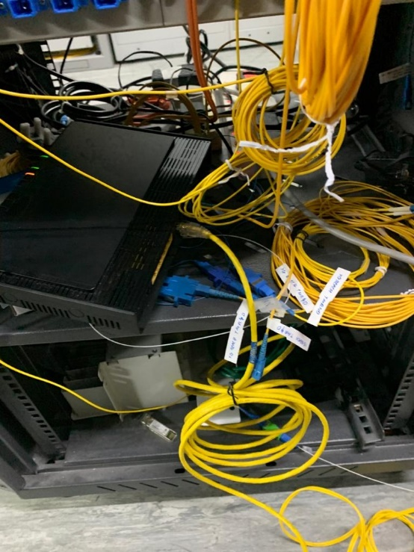

* Fortunately, the troubleshoot was done and the problem was solved by Miss Syikin, who is expert on switch configuration. The system setup was brought back to MMU and testing result was successful. The transmission successful achieve 10G speed from CBJ2 to MMU. The result was shown in figure below.

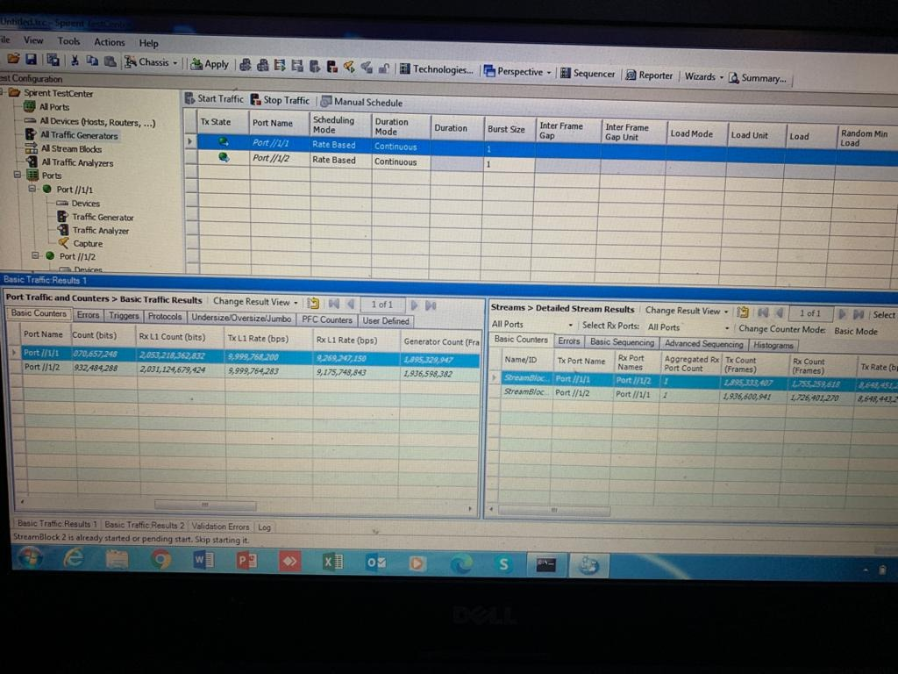

* The configuration on Wi-Fi 6 was still in progress. The Wi-Fi link on ASUS ROG Rapture GT router was not up because some issues on PPPoE account.